MARKETING CAMPAIGN PERFORMANCE ANALYSIS – PROJECT REPORT

1. Introduction

This project focuses on analysing the performance of various marketing campaigns to understand which campaign types generate the highest revenue, profit, and return on investment (ROI). The analysis evaluates campaign effectiveness across multiple channels and audience segments, helping businesses optimize their marketing budgets and maximize profitability.

Using marketing campaign data, the study identifies trends in customer engagement, campaign efficiency, conversion performance, and overall business impact.

The insights generated support data-driven decision-making for marketing strategy, budget allocation, and future campaign planning.

2. Dataset Overview
The dataset contains information about multiple marketing campaigns executed across different channels and target audiences.
Key Data Fields Include:
Campaign Information
- Campaign Name
- Campaign Type
- Marketing Channel
- Target Audience
Financial Metrics
- Revenue
- Profit
- Campaign Cost
- ROI (%)
- ROAS
Performance Metrics
- Impressions
- Clicks
- CTR (Click Through Rate)
- Conversion Rate
- CPC (Cost Per Click)
- CPA (Cost Per Acquisition)
Engagement Metrics
- Customer Interactions
- Leads Generated
- Conversions
The dataset provides a comprehensive view of campaign performance and allows comparison across marketing strategies.

3. Data Preprocessing & Python-Based Exploration

Data cleaning, transformation, and exploratory analysis were performed using Python libraries such as Pandas, NumPy, Matplotlib, and Seaborn. The objective was to prepare the marketing campaign dataset for detailed business analysis and dashboard development.

3.1 Initial Data Inspection
The dataset was imported into a Pandas DataFrame and examined using various exploratory functions.
Activities performed:
- Loaded the dataset using Pandas.
- Checked dataset dimensions using .shape.
- Displayed sample records using .head().
- Reviewed column names and data types using .columns and .info().
- Generated descriptive statistics using .describe().
- Verified the number of unique campaigns.
- Analyzed campaign category distribution.
These steps provided a comprehensive understanding of the dataset structure and quality.

3.2 Data Quality Assessment
The dataset was evaluated for potential data quality issues.
Checks performed:
- Identified missing values using .isnull().sum().
- Checked duplicate records using .duplicated().sum().
The dataset showed a clean structure with no major inconsistencies affecting the analysis.

3.3 Date Transformation
The campaign date column (c_date) was converted into datetime format to enable time-based analysis.
Additional date-related features were extracted:
- Year
- Month Number
- Month Name
- Quarter
These attributes support trend analysis across different time periods.

3.4 Marketing KPI Feature Engineering
Several key marketing performance indicators were calculated to evaluate campaign effectiveness.
- Click Through Rate (CTR)
  - CTR measures the percentage of users who clicked on an advertisement after viewing it.
  - CTR = (Clicks ÷ Impressions) × 100
- Lead Conversion Rate
  - Measures the percentage of clicks that generated leads.
  - Lead Conversion Rate = (Leads ÷ Clicks) × 100
- Order Conversion Rate
  - Measures the percentage of leads converted into actual orders.
  - Order Conversion Rate = (Orders ÷ Leads) × 100

3.5 Financial Performance Metrics
To evaluate campaign profitability and efficiency, several business metrics were created.
- Return on Advertising Spend (ROAS)
  - ROAS = Revenue ÷ Marketing Spend
  - This metric indicates the revenue generated for every unit of advertising expenditure.
- Return on Investment (ROI)
  - ROI = ((Revenue − Marketing Spend) ÷ Marketing Spend) × 100
  - ROI measures the profitability of marketing investments.
- Cost Per Click (CPC)
  - CPC = Marketing Spend ÷ Clicks
  - Used to evaluate the cost efficiency of attracting website traffic.
- Cost Per Lead (CPL)
  - CPL = Marketing Spend ÷ Leads
  - Measures the average cost incurred to generate a lead.
- Customer Acquisition Cost (CAC)
  - CAC = Marketing Spend ÷ Orders
  - Represents the average cost required to acquire a paying customer.
- Profit
  - Profit = Revenue − Marketing Spend
  - This metric was created to directly measure campaign profitability.

3.6 Data Export
After cleaning and feature engineering, the final processed dataset was exported as:
- marketing_cleaned.csv
The cleaned dataset served as the primary source for SQL analysis and Power BI dashboard creation.

3.7 Exploratory Analysis
Initial exploratory analysis was performed to identify campaign performance trends.
Analyses conducted include:
- Revenue by Campaign Name
- Profit by Campaign Name
- Average ROI by Campaign
Visualization techniques using Matplotlib were used to compare campaign effectiveness and identify high-performing marketing strategies.

3.8 PostgreSQL Integration
The final processed dataset was imported into PostgreSQL using SQLAlchemy.
Steps performed:
- Established connection with PostgreSQL database.
- Created a dedicated database for marketing analytics.
- Imported the cleaned dataset into a relational table.
- Prepared the data for advanced SQL-based business queries and reporting.
This integration enabled efficient querying and supported the development of analytical insights used in the Power BI dashboard.

4. SQL Analysis & Business Queries
After preprocessing the dataset, PostgreSQL was used to perform business-oriented analysis on marketing campaign performance. SQL queries were executed to evaluate revenue generation, marketing expenditure, profitability, and campaign effectiveness.
4.1 Total Revenue Analysis
The first query calculated the overall revenue generated by all marketing campaigns.
Objective:
- Measure total business revenue.
- Understand the overall financial impact of marketing activities.
SQL Function Used:
- SUM()
- ROUND()
Insight:
This KPI serves as a primary indicator of marketing success and overall campaign performance.

4.2 Total Marketing Spend Analysis
The total amount invested in marketing campaigns was calculated using SQL aggregation functions.
Objective:
- Determine total advertising expenditure.
- Compare spending against generated revenue.
SQL Function Used:
- SUM()
- ROUND()
Insight:
This metric provides the foundation for calculating profitability and return-based performance indicators.

4.3 Revenue by Campaign Analysis
Revenue generated by each campaign was analyzed and ranked in descending order.
Objective:
- Identify top-performing campaigns.
- Compare revenue contribution across different marketing strategies.
SQL Operations Used:
- GROUP BY
- SUM()
- ORDER BY DESC
Insight:
Campaigns generating the highest revenue can be considered strong candidates for increased budget allocation and future scaling.

4.4 Profit by Campaign Analysis
Profitability of each campaign was evaluated by aggregating campaign profits.
Objective:
- Identify campaigns generating maximum profit.
- Compare profitability beyond revenue figures.
SQL Operations Used:
- GROUP BY
- SUM()
- ORDER BY DESC
Insight:
A campaign with high revenue may not always generate the highest profit. Profit analysis helps identify campaigns that efficiently convert marketing investment into business returns.

4.5 Financial Performance Comparison
Revenue and profit metrics were compared to assess campaign effectiveness.
Key Questions Addressed:
- Which campaigns generate the highest revenue?
- Which campaigns generate the highest profit?
- Are the highest revenue campaigns also the most profitable?
Business Value:
This comparison helps organizations focus on campaigns that not only attract customers but also maximize profitability.

4.6 Campaign Performance Ranking
Campaigns were ranked based on:
- Total Revenue
- Total Profit
Purpose:
- Identify best-performing campaigns.
- Support future marketing budget decisions.
- Highlight campaigns suitable for replication and expansion.

4.7 Summary of SQL Findings
The SQL analysis successfully provided:
- Total Revenue generated by all campaigns.
- Total Marketing Spend invested.
- Revenue contribution of individual campaigns.
- Profit generated by individual campaigns.
- Campaign rankings based on financial performance.
These insights formed the basis for the Power BI dashboard and helped identify the most successful marketing campaigns from both revenue and profitability perspectives.

5. Interactive Dashboard in Power BI
An interactive Power BI dashboard was developed to visualize and compare the performance of different marketing campaigns. The dashboard enables users to evaluate revenue generation, marketing expenditure, campaign effectiveness, customer engagement, and return on investment through dynamic visualizations and filters.
5.1 Dashboard Overview
The dashboard provides a centralized view of campaign performance metrics and allows users to compare campaigns across multiple categories.
Key objectives include:
- Monitoring campaign performance.
- Comparing revenue and marketing spend.
- Evaluating ROI across campaigns.
- Tracking customer engagement metrics.
- Supporting data-driven marketing decisions.
5.2 KPI Cards
The dashboard includes the following Key Performance Indicators (KPIs):
- Total Revenue
  - Displays the total revenue generated by all campaigns.
  - Value: 42.89 Million
- Total ROI
  - Displays the cumulative ROI generated by marketing campaigns.
  - Value: 12.55 Thousand
- Campaign Categories
  - Displays the total number of campaign categories analyzed.
  - Value: 4 Categories
- These KPIs provide a quick summary of overall marketing performance.
5.3 Campaign Filter
A campaign name slicer is provided on the left side of the dashboard.
Features:
- Enables campaign-specific analysis.
- Allows users to compare individual campaign performance.
- Dynamically updates all visualizations based on selected campaigns.
Example campaigns include:
- banner_partner
- facebook_lal
- facebook_retargeting
- Other campaign variations
5.4 Revenue vs Marketing Spend by Category
A clustered bar chart compares:
- Total Revenue
- Total Marketing Spend
Across categories such as:
- Influencer Marketing
- Social Media Marketing
- Media Campaigns
- Search Marketing
Purpose:
- Evaluate campaign profitability.
- Identify categories generating maximum revenue relative to spending.
- Support budget optimization decisions.
5.5 ROI Percentage by Campaign
A column chart displays ROI percentages for individual campaigns.
Purpose:
- Identify high-performing campaigns.
- Detect campaigns generating negative returns.
- Compare investment efficiency across campaigns.
Key Insight:
Several campaigns achieved exceptionally high ROI values, while a few campaigns produced negative returns, indicating opportunities for optimization.
5.6 Impressions by Category
A bar chart visualizes total impressions generated by each marketing category.
Purpose:
- Measure audience reach.
- Compare campaign visibility across categories.
- Understand brand exposure performance.
Observation:
Media campaigns generated the highest number of impressions among all categories.
5.7 Orders by Category
A column chart presents the number of orders generated by each marketing category.
Purpose:
- Evaluate conversion effectiveness.
- Compare sales performance across channels.
Observation:
Influencer and Social Media campaigns generated the highest order volumes.
5.8 Clicks by Category
A bar chart displays total clicks generated by each marketing category.
Purpose:
- Measure audience engagement.
- Evaluate campaign attractiveness and effectiveness.
Observation:
Social Media campaigns generated the highest click volume, indicating strong customer engagement.
5.9 Dashboard Interactivity
The dashboard incorporates interactive features including:
- Campaign Name Filters
- Cross-Filtering Between Visuals
- Dynamic KPI Updates
- Category-Based Comparisons
These features enable users to perform detailed campaign analysis and explore performance trends efficiently.
5.10 Business Value of the Dashboard
The dashboard helps stakeholders:
- Identify top-performing campaigns.
- Monitor marketing expenditure.
- Compare ROI across campaigns.
- Track customer engagement metrics.
- Make informed budget allocation decisions.
- Optimize future marketing strategies.
The dashboard serves as an effective decision-support tool for evaluating marketing campaign performance and maximizing return on investment.
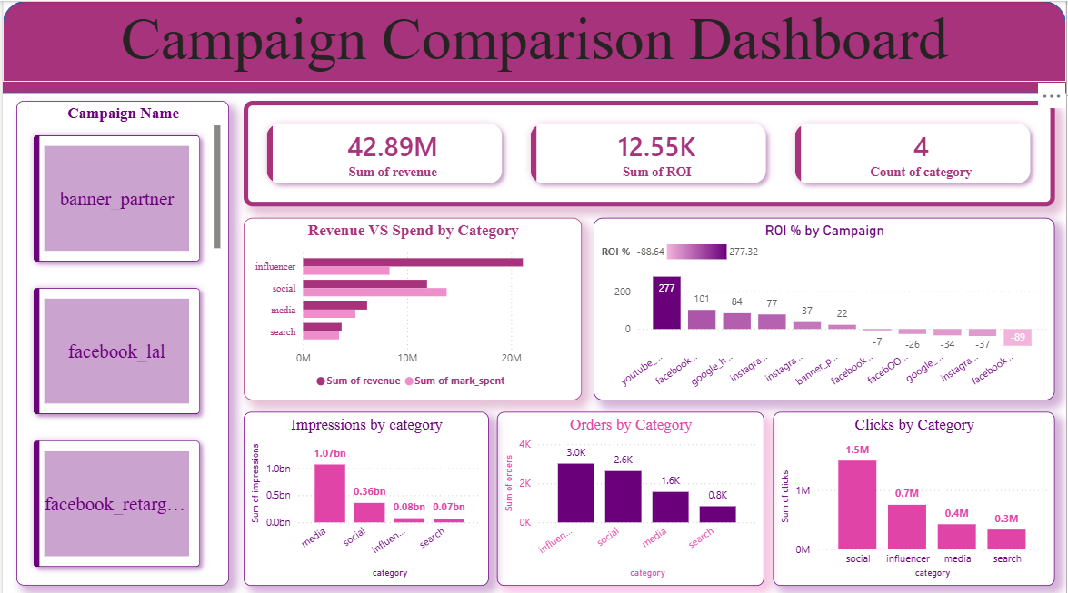

6. Business Insights & Recommendations
Based on the analysis of marketing campaign performance using Python, PostgreSQL, and Power BI, several valuable insights were identified that can help organizations improve marketing effectiveness, optimize spending, and maximize returns.
6.1 Focus on High-Revenue Campaigns
The campaign-wise revenue analysis revealed that certain campaigns contribute significantly more revenue than others.
Recommendations:
- Increase budget allocation for top-performing campaigns.
- Replicate successful campaign strategies across similar marketing channels.
- Analyze the factors driving higher revenue generation.
Business Value:
Focusing on high-revenue campaigns can significantly increase overall business growth while improving marketing efficiency.

6.2 Prioritize High-ROI Campaigns
The ROI analysis showed considerable variation in campaign performance, with some campaigns generating exceptionally high returns while others produced low or negative ROI.
Recommendations:
- Scale campaigns with consistently high ROI.
- Reassess or discontinue campaigns generating negative returns.
- Continuously monitor ROI before increasing marketing expenditure.
Business Value:
Investing in campaigns with proven ROI ensures better utilization of marketing budgets and improves profitability.

6.3 Optimize Marketing Spend
The Revenue vs Marketing Spend analysis indicated that higher spending does not always guarantee higher revenue.
Recommendations:
- Focus on cost-efficient campaigns.
- Reduce spending on underperforming campaigns.
- Implement regular budget performance reviews.
Business Value:
Optimized spending helps maximize returns while minimizing unnecessary marketing costs.

6.4 Strengthen Social Media Marketing
The dashboard revealed strong engagement levels through Social Media campaigns, generating high click volumes and customer interactions.
Recommendations:
- Expand social media advertising efforts.
- Increase investment in high-performing social platforms.
- Develop more audience-focused content strategies.
Business Value:
Higher engagement increases brand awareness and improves the likelihood of conversions.

6.5 Improve Search and Low-Performing Categories
Certain campaign categories generated lower impressions, clicks, and orders compared to others.
Recommendations:
- Review targeting strategies.
- Improve ad creatives and messaging.
- Conduct A/B testing to identify more effective campaign variations.
Business Value:
Enhancing weaker campaigns can improve overall marketing performance and increase campaign reach.

6.6 Leverage Influencer Marketing
The dashboard showed that influencer campaigns generated strong order volumes and revenue performance.
Recommendations:
- Collaborate with high-performing influencers.
- Expand influencer partnerships in relevant market segments.
- Track influencer-specific ROI and conversion metrics.
Business Value:
Influencer marketing can improve trust, engagement, and customer acquisition at scale.

6.7 Use Data-Driven Campaign Monitoring
The Power BI dashboard provides real-time visibility into campaign performance.
Recommendations:
- Monitor KPIs regularly.
- Track revenue, profit, ROI, ROAS, clicks, and orders.
- Use dashboard insights for future campaign planning.
Business Value:
Data-driven decision-making enables faster optimization and improved marketing outcomes.

7. Conclusion
This project successfully analyzed marketing campaign performance using Python, PostgreSQL, and Power BI to evaluate the effectiveness of various marketing strategies and their contribution to business growth.
Key Achievements
- Cleaned and transformed raw marketing campaign data using Python.
- Created important performance metrics such as CTR, ROI, ROAS, CPC, CPL, CAC, and Profit.
- Performed SQL-based business analysis to evaluate revenue, marketing spend, and campaign profitability.
- Developed an interactive Power BI dashboard for campaign comparison and performance monitoring.
- Generated actionable insights for budget optimization and campaign improvement.
The analysis demonstrated that not all campaigns contribute equally to business success. While some campaigns generated significant revenue and high ROI, others required optimization to improve profitability and engagement. By leveraging data analytics, organizations can make informed decisions regarding marketing investments, campaign selection, and resource allocation.
Overall, this project highlights the importance of combining Python, SQL, and Power BI to transform raw marketing data into meaningful business insights that support strategic decision-making and maximize return on marketing investment.

